

**CSE302 (Section 1)**

**[Summer 2022]**

**Lab Assignment Submission Report**

**Assignment Title: Lab 2**

**Submitted by:**

**MD. ASIF HASAN**

**2020-1-60-079**

**Screenshots**

**Problem 1:**

**3 table created (Account, Customer & Depositor)**

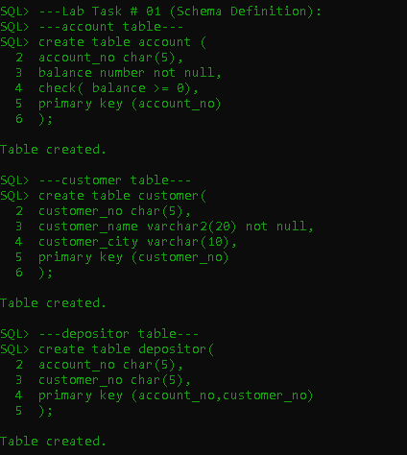

**Problem 2:**

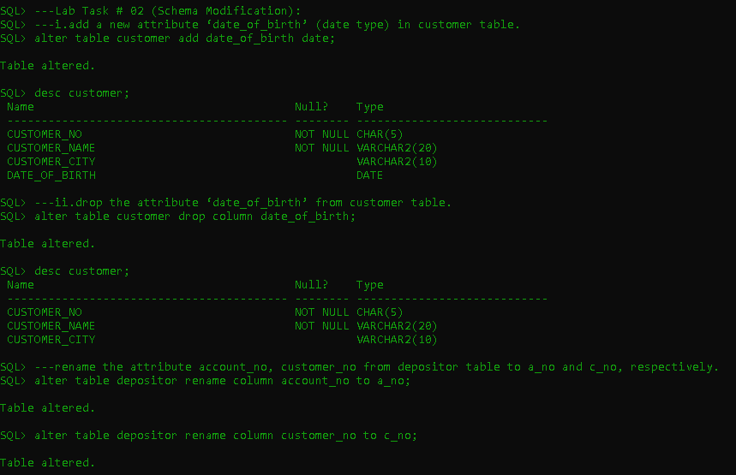**Modifying table**

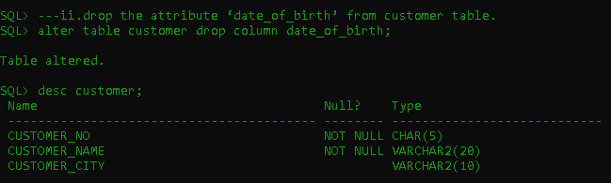

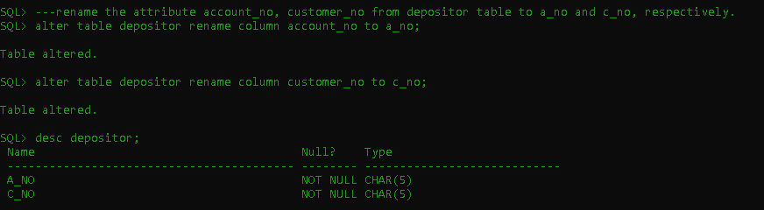

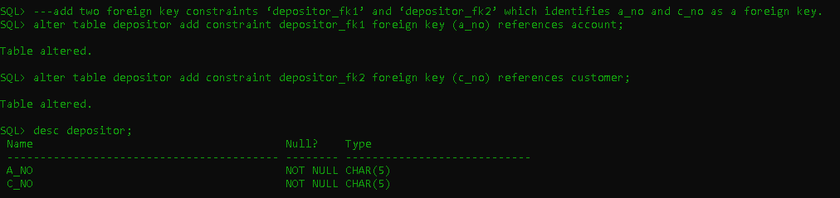

**Problem 3:**

**Input data**

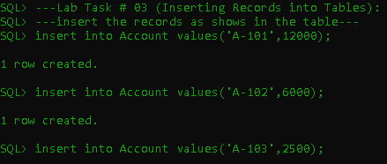

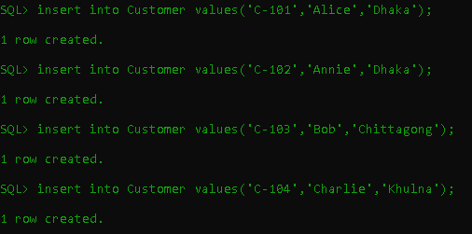

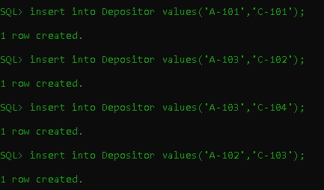

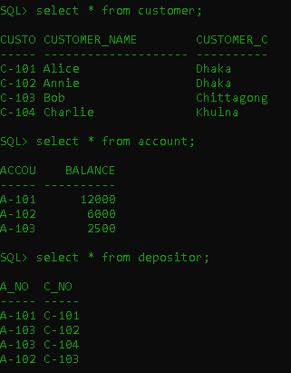

**Problem 4:**

**Queries**

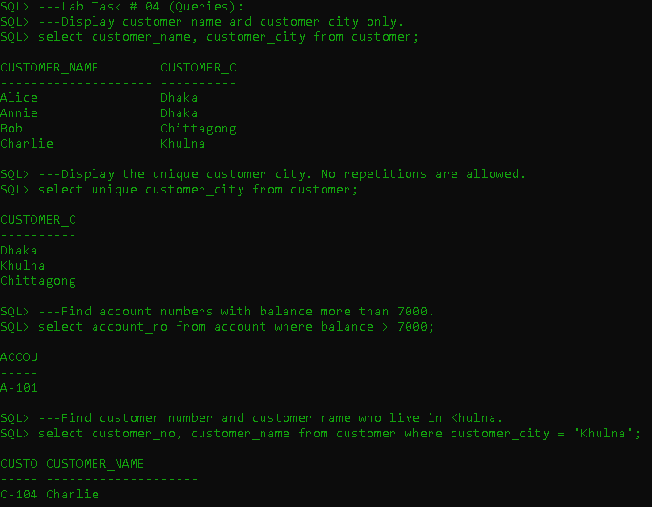

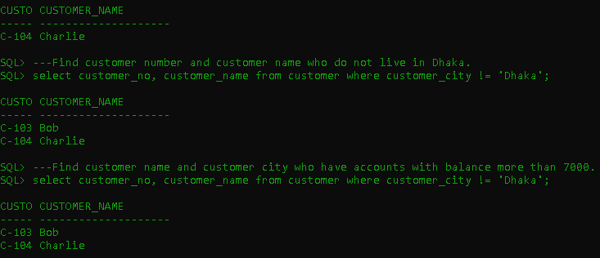

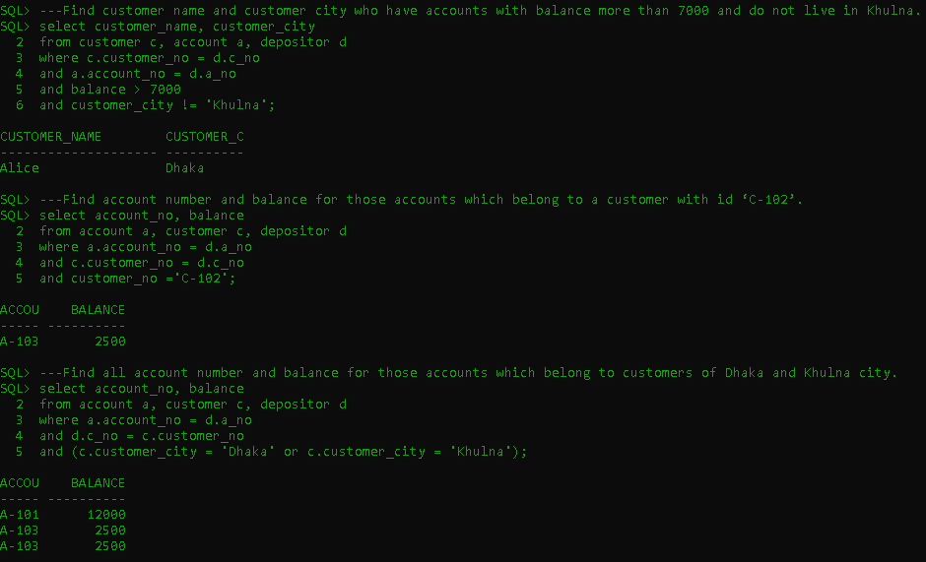

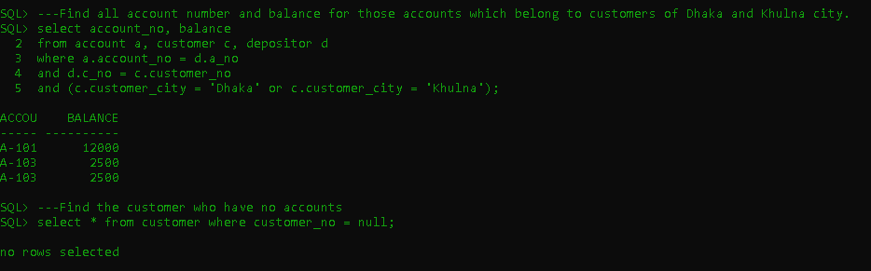

Learning Outcomes

1. **Create & Read a table**
2. **Modify table name, column name, add or delete new columns, adding new constraint**
3. **Adding new data in table**
4. **Show different types of data with queues.**
   1. **Single table query**
   2. **Multi table query**